Unix Programming
Week 3

Chap 8 Exercize :

1) For files and directories they must follow this list of characters:
- Uppercase letters ( A to Z)
- Lowercase letters (a to z)
-Numerals (0 to 9)
-Period (.), undersocre(-) and coma(,)
They should avoid other caracters and space in the name. (Directories should start with an uppercase letter)

2) The absolute pasthname for « your » home directory is : ‘/’
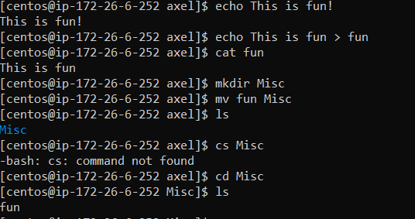
3)

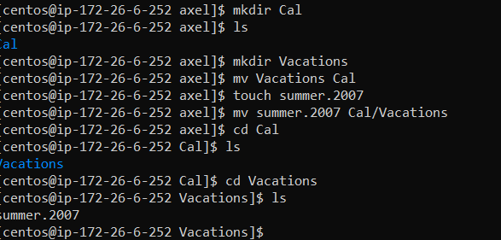
4)

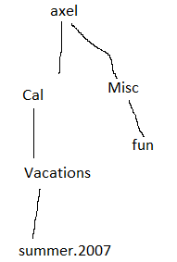
5)

